Virologica Sinica

Supplementary materials

First complete genomic sequence analysis of canine distemper virus in wild boar

Tong Wang a, b, Haiying Du b, Na Feng b, Yuhang Liu a, b, Yu Xu c, Heting Sun c, Peng Peng c, Siyuan Qin c, Xiaotian Zhang c, Yan Liu c, Mingyuan Yu c, Hongrui liang c, Biao He b, Guoqiang Zhu a, *, Changchun Tu a, b, *, Zhongzhong Tu b, *

a Jiangsu Co-Innovation Center for the Prevention and Control of Important Animal Infectious Disease and Zoonoses, Yangzhou University, Yangzhou 225009, China;

b Changchun Veterinary Research Institute, Chinese Academy of Agricultural Sciences, Changchun 130122, China;

c Biological Disaster Control and Prevention Center, National Forestry and Grassland Administration, Shenyang 110034, China;

*Corresponding authors:

Email addresses: tudong890901@163.com (Z. Tu); changchun_tu@hotmail.com (C. Tu); yzgqzhu@yzu.edu.cn (G. Zhu).

ORCID: 0000-0002-5491-0670 (G. Zhu), 0000-0002-8134-7502 (C. Tu), [0000-0003-1079-2710](https://orcid.org/0000-0003-1079-2710) (Z. Tu).

**Materials and methods**

*Sample information*

Between August 2018 and December 2022, 582 tissue samples (tonsil, spleen, liver, kidney, lung and lymph node) and 60 serum samples were collected from 97 wild boars in Heilongjiang, Jilin, and Liaoning provinces (Gong et al., 2023). The samples were transported under refrigerated conditions to the laboratory and stored at −80 °C until use.

*Virus metagenomic analysis*

Viral metagenomic analysis was performed using meta-transcriptomic (MTT) protocol as previously described (Jiang et al., 2022; Sun et al., 2022). Briefly, the centrifuged supernatant of 20% tissue homogenates were filtered through 0.45 μm filters, and 400 μL aliquots of the filtrates were processed for total RNA extraction using TRIzol reagent (Invitrogen, Carlsbad, CA, USA) according to the manufacturer’s instructions. After removal of rRNA and precipitation of the remaining RNA by ethanol, the RNA was used to construct a long noncoding RNA library, followed by high-throughput sequencing using the Illumina Novaseq 6000 platform.

*Virus detection by RT-qPCR*

Tissue samples from each boar were mixed and processed as 10% homogenates in minimal essential medium (MEM, Corning, NY, USA). Clarified supernatants were then subjected to total RNA extraction using the TIANamp Virus RNA Kit (TIANGEN, Beijing, China) according to the manufacturer’s instructions. The obtained RNA was reverse transcribed into cDNA using random primers and Moloney murine leukemia virus Reverse Transcriptase (TaKaRa, Dalian, China), with the resulting cDNA serving as a template for RT-qPCR (amplify a conserved 83-bp fragment of CDV N protein gene) as previously described (Elia et al., 2006).

*Alignment and phylogenetic analysis*

Representative full-length hemagglutinin gene (*H*) and complete genomes of geographically distinct CDV lineages were retrieved from GenBank (Supplementary Table S2). Phylogenetic analyses were performed using Clustal W and Molecular Evolutionary Genetics Analysis software MEGA 7.0 (Center for Evolutionary Functional Genomics, Tempe, AZ). For sequence analysis, phylogenetic trees based on the *H* and complete genomes were constructed using the neighbor-joining (NJ) method with 1000 bootstrap replications.

*Seroprevalence of wild boars CDV infection in Northeast China*

A serological survey of antibodies against CDV in wild boars was performed using virus-neutralization (VN) tests as previously described (Cha et al., 2012). Briefly, 2-fold dilutions of the serum (ranging from 1:4 to 1:128) were incubated with 100 TCID50 CDV for 1 h prior to addition onto Vero cell monolayers in 96-well plates. After 72 h incubation at 37 °C and 5% CO2 humidity, the wells were observed using an inverted microscope at 50× magnification for cytopathic effects (CPE). Titers ≥ 1:16 were considered positive. The VN titers were calculated using the method of Reed and Münch.

**Reference**

Gong W, Du H, Wang T, Sun H, Peng P, Qin S, Geng H, Zeng Z, Liang W, Ling H, Tu C, Tu Z. 2023. Epizootiological surveillance of porcine circoviruses in free-ranging wild boars in china. Virol Sin, 38: 663-670.

Jiang J, Hao Y, He B, Su L, Li X, Liu X, Chen C, Chen L, Zhao Z, Mi S, Deng X, Gong W, Tu C. 2022. Severe acute hepatitis outbreaks associated with a novel hepacivirus in rhizomys pruinosus in hainan, china. J Virol, 96: e0078222.

Sun Y, Qu Y, Yan X, Yan G, Chen J, Wang G, Zhao Z, Liu Y, Tu C, He B. 2022. Comprehensive evaluation of RNA and DNA viromic methods based on species richness and abundance analyses using marmot rectal samples. mSystems, 7: e0043022.

Elia G, Decaro N, Martella V, Cirone F, Lucente MS, Lorusso E, Di Trani L, Buonavoglia C. 2006. Detection of canine distemper virus in dogs by real-time RT-PCR. J Virol Methods, 136: 171-176.

Cha SY, Kim EJ, Kang M, Jang SH, Lee HB, Jang HK. 2012. Epidemiology of canine distemper virus in wild raccoon dogs (nyctereutes procyonoides) from south korea. Comp Immunol Microbiol Infect Dis, 35: 497-504.

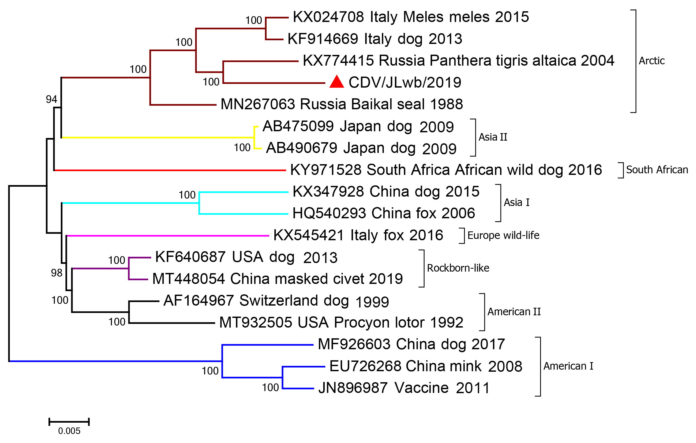

**Figure S1** Phylogenetic analysis of canine distemper virus based on the complete genome sequence.

Table S1 Hemagglutinin protein amino acid mutations in CDV Arctic lineage strains

|  |  |  |  |  |  |  |  |  |
| --- | --- | --- | --- | --- | --- | --- | --- | --- |
| Amino acid mutation site | Genotype lineages | | | | | | | |
| Asia I | Asia II | Asia III | American I | American II | Europe wild-life | South African | Arctic |
| 2 | L | L | L | L | L | L | L | L/F |
| 9 | G | G | G | G | G | G/S | G | G/A |
| 20 | S | S | S | S/P | S | S | S | L |
| 35 | P | P | P | P | P | P | P | P/S |
| 65 | T | T | T | T | T | T | T | T/I |
| 82 | E | E | E | E | E | E | E | D |
| 119 | L | L | L | L | L | L | L | L/I |
| 155 | D | D | D | D/E | D | D | D | D/E |
| 197 | R | R | R | K | R/S | R | R | K/E |
| 198 | V | V | V | V | V | V | V | S |
| 222 | A | A | A | A | A | A | A | A/S |
| 241 | G | R | K | R | G | G | G | G/E |
| 260 | L | L | L | L | L | L | L | L/V |
| 266 | L | L | L | L | L/F | L | L | F |
| 273 | V | V | I | V | V | V | V | T/I |
| 280 | A | A | A | A | A | A | A | A/T |
| 282 | V | V | V | V | V | V | V | V/I |
| 298 | D | D | D | D/E | D | D/G | G | D/E |
| 300 | S | S | S | S | S | S | S | S/N |
| 327 | P | P | P | P/S | P | P | P | P/S |
| 335 | I | I | I | I | I | I | I | I/T |
| 358 | I | V | V | I | I | I | I | V |
| 371 | Q | Q | L | Q | Q | Q | Q | L |
| 373 | E | G | G | E | E | E | E | E/D |
| 379 | E | E | E | E | E | E | E | E/K |
| 412 | P | P | P | P | P/S | P/S | P | P/H |
| 419 | L | L | L | L | L/P | L | L | L/R |
| 447 | S | S | S | S | S | S/F | S | S/F |
| 480 | T | T | T | T | T | T | T | T/S |
| 530 | G | E | R | N | R/G | N/D | N | N/G |
| 538 | V | V | V | V | V | V | V | V/I |
| 548 | T | T | T | T | T/M | T | T | T/M |
| 549 | Y | Y | Y | Y/H | Y/H | Y/H | Y | Y/H |
| 570 | D | D | D | D | D | D/G | D | D/N |
| 571 | D | D | D | D | D | D/Y | D | D/G/E |
| 594 | N | D | D | N | N | N | N | N/K |
| 599 | R | R | R | R | R | R | R | R/K |
| 605 | S/* | S | S | S | S | S | S | S/* |

*Amino acid position encoded by the stop codon

Table S2 GenBank accession numbers of CDV strains used for phylogenetic analysis

|  |  |  |  |  |
| --- | --- | --- | --- | --- |
| No. | Strain | Country | Host | Accession no. |
| 1 | HLJ1-06 | China | fox | HQ540293 |
| 2 | SC01 | China | raccoon dog | EF042818 |
| 3 | TN | China | dog | AY390347 |
| 4 | 5VD | Japan | dog | AY297454 |
| 5 | 009L | Japan | dog | AB252718 |
| 6 | HLJ1 | China | dog | EU743934 |
| 7 | HLJ2 | China | fox | EU743935 |
| 8 | Snyder Hill | USA | dog | JN896987 |
| 9 | 98-2646 | USA | raccoon | AY542312 |
| 10 | 98-2654 | USA | raccoon | AY466011 |
| 11 | 00-2601 | USA | raccoon | AY438597 |
| 12 | 01-2690 | USA | raccoon | AY465925 |
| 13 | A92-27/4 | China | Chinese leopard | Z54156 |
| 14 | Javelina/US89 | USA | javelina | Z47764 |
| 15 | 111/03B | Italy | dog | DQ494319 |
| 16 | 2390-07 | Austria | stone marten | GQ214369 |
| 17 | H06Ny11 | Hungary | dog | DQ889187 |
| 18 | CDV3 | China | Vero cell lysate | DQ778941 |
| 19 | Shuskiy | Kazakhstan | mink | HM063009 |
| 20 | PS88-428 | Russia | Baikal seal | MN267063 |
| 21 | CDV11956/2015 | Italy | Meles meles | KX024708 |
| 22 | CDV2784/2013 | Italy | dog | KF914669 |
| 23 | liud | China | dog | AF172411 |
| 24 | HL | China | fox | EF445052 |
| 25 | Phoca/Caspian/2007 | Kazakhstan | seal | HM046486 |
| 26 | 1sp | South Africa | dog | FJ461696 |
| 27 | 7L | South Africa | dog | FJ461711 |
| 28 | 21L | South Africa | dog | FJ461694 |
| 29 | 265/02-3 | Italy | dog | DQ494318 |
| 30 | H06Ny13 | Hungary | dog | DQ889189 |
| 31 | Danish mink | Denmark | mink | Z47759 |
| 32 | Pt61/Pt 2004 | Russia | Panthera tigris altaica | KX774415 |
| 33 | Pt79H | Russia | Panthera tigris altaica | KX708720 |
| 34 | FELeopard2015H | Russia | Panthera pardus orientalis | MK169401 |
| 35 | FUR0309H | Russia | Meles leucurus | KX708718 |
| 36 | R252 | USA | dog | KF640687 |
| 37 | CDV/HN19 | China | masked civet | MT448054 |
| 38 | A75/17 | Switzerland | dog | AF164967 |
| 39 | 55L | Japan | dog | AB475099 |
| 40 | CDV3 | China | mink | EU726268 |
| 41 | 007Lm/H | Japan | dog | AB490679 |
| 42 | BJ16C8 | China | dog | MF926603 |
| 43 | CDV-AH | China | dog | KX347928 |
| 44 | PLO004 | USA | Procyon lotor | MT932505 |
| 45 | WT01SA | South Africa | African wild dog | KY971528 |
| 46 | CDV599/2016 | Italy | fox | KX545421 |
| 47 | HLJ1-06 | China | fox | HQ540293 |